Sean Christopher Stork BARITONE  www.SeanStork.com | seans2576@gmail.com  (407) 435-8043 | 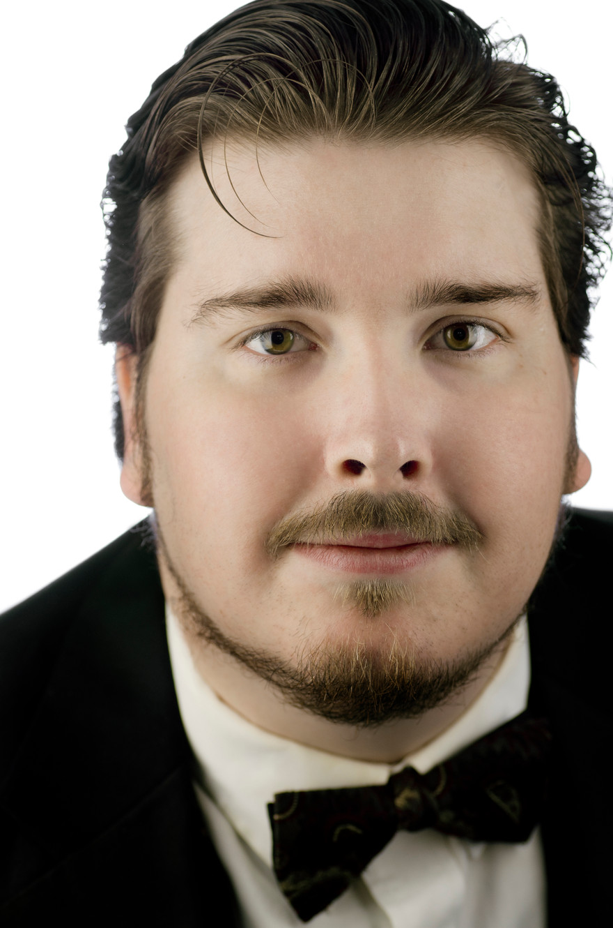
Upcoming Roles
Sciarrone  Fiorello/Officer | Tosca  Il barbiere di Siviglia | Opera Tampa  Opera Tampa | April 23, 2027  February 5, 2027
Opera Roles
Medico/Sicario  Conductor  Soloist  Horace Derwent  Spider  Benoit/Alcindoro  Papageno  Martin/Grand Inquisitor  Dr Malatesta  Baron Douphol  Peter  Apollo/Pastore/Eco  Imperial Commissario  Æneas  Fiorello/Officer  Le Podestad  Marco  Ivan Ilych | Macbeth  The Mikado  Brahms Requiem  The Shining  Mukha-Tsokotukha  La Boheme  The Magic Flute  Candide  Don Pasquale  La Traviata  Hansel and Gretel  L’Orfeo  Madama Butterfly  Dido and Æneas  Il barbieri di Siviglia  Docteur Miracle  Gianni Schicchi  The Death of Ivan Ilych* | Opera Tampa  First Coast Opera  Riverside Orchestra and Chorale  Opera Tampa  Musical Traditions  Opera Tampa  First Coast Opera  Opera Tampa  Sunnyside Opera  Opera Tampa  Opera Tampa  Florida Atlantic University  Lakeland Opera  Capella Nova  Gulfshore Opera  First Coast Opera  Opera Tampa  Opera Orlando | 2026  2026  2026  2026  2025  2025  2025  2025  2024  2024  2024  2024  2024  2023  2023  2022  2022  2021
Operetta/Musical Theater Roles
Dennis  Luigi  Richard "Dick" Banks  Birdseller/Quintet  CEO  Major General Stanley  Hans Christian Anderson  Cox  Storyteller  Melchior | Considering Matthew Shepard  The Last Hurdy Gurdy*  The Impresario  Sweeney Todd  The Important Problem*  Pirates of Penzance  The Trial of B.B. Wolf  Penelope Ann's Revenge*  The Greatest Story*  Amahl and the Night Visitors | Solaria  Pinellas Opera League  Orlando Fringe Festival  Opera Tampa  Timucua Arts Foundation  Opera Tampa  First Coast Opera  First Coast Opera  Gaylord Palms Resort  Opera Orlando | 2024  2024  2023  2023  2023  2022  2022  2020  2019  2019
Education
Independent Voice Studies- Dr. Jamison Walker 2017-2018
Florida State University- BA in Voice Performance: Graduated 2007
Florida State University- Voice Studies- Prof. Larry Gerber: 2003-2007
Master Classes:  Nicholas Giusti  Jake Gardner  David Okerlund | Coaches  Robin Stamper  Frederico Bardazzi  Douglas Fisher | Directors  Dean Anthony  Melissa Misener  Frank Mcclain | Conductors  Anthony Barrese  Noam Aviel  Jorge Parodi
*World Premiere Performance

